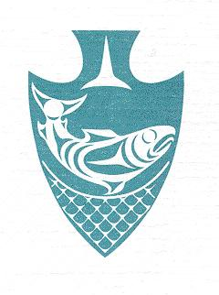
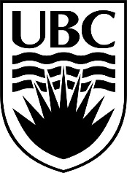
15th Annual Musqueam and UBC

Youth Soccer Tournament

Awards Summary – 10 & Under

All Star Awards
Team | Female | Male
- Sts’ailes Jr. Cheifs A
- Tsleil-Waututh Jr Warriors
- Musqueam Blues
- Cowichan Eagles A
- VanCity United
- Sts’ailes Jr. Chiefs B
- Squamish Thunder
- Sechelt
- Cowichan Eagles B

Special Awards
Award | Team | Name
Best Goalie
Best Defensive Player
Best Offensive Player
Most Valuable Player

Final Standings
3rd Place:
2nd Place:
1st Place:

