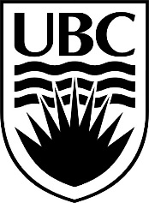
15th Annual Musqueam and UBC

Youth Soccer Tournament

Awards Summary – 13 & Under

All Star Awards
Team | Female | Male
- Cowichan Eagles
- Sts’ailes Thunderbirds
- Sechelt
- Cheam Selects
- Tsleil Waututh Jr. Warriors
- Musqueam Blues
- Musqueam Spurs
- Salish Storm

Special Awards
Award | Team | Name
Best Goalie
Best Defensive Player
Best Offensive Player
Most Valuable Player

Final Standings
3rd Place:
2nd Place:
1st Place:

