Resident May 9th, 2018

Re: 15th Annual Musqueam and UBC Youth Soccer Tournament

Firstly I would like to thank you for your continued support of the Annual Musqueam and UBC Youth Soccer Tournament. This year’s event will be our 15th Annual tournament and will take place Saturday May 19th and Sunday May 20th, 2017. This tournament is a fantastic opportunity for youth to experience sport in a friendly and safe environment and to interact with their families and youth from other nations. Over the years the tournament has grown in popularity, largely due to our focus on creating a memorable event for the youth.

During the tournament this year we will be limiting parking around the soccer fields to elders and handicap parking only. Our Safety and Security Department will be blocking off entrances to the leasehold lands and will be monitoring all those who enter to gain access to their homes or the tournament itself. Entrances will be blocked from 7:00 am – 7:00 pm daily. We have included with this letter two passes for your household. Please have these displayed in your vehicle (s) for the duration of the tournament, including when your car is parked on the street near your home. We hope that by engaging our Safety and Security team to help manage parking this will allow for an enjoyable weekend for everyone. If you have any concerns during the tournament please see the parking attendants on site.

Sincerely,

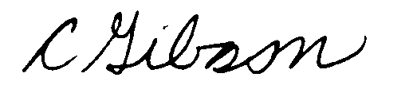

Courtenay Gibson
Recreation Coordinator
cgibson@musqueam.bc.ca
604.781.1470
604.269.3451

